**Cairo university**

**Faculty of Engineering**

**Credit Hours System**

**Area Limits Calculator**

Table of Contents

|  |  |
| --- | --- |
| Content | Pages |
| Introduction | 3 |
| Research Made | 4 |
| Our Approach | 5🡪7 |
| GUI Implementation | 7🡪10 |
| Samples of inputs & corresponding outputs | 10🡪11 |
| How to use our program? | 12 |
| Conclusion | 12 |

##### **Introduction**

Our aim from this project was to open things up a little bit in programming in general using our course knowledge of MATLAB and its user-friendly IDE (Integrated Development Environment).

So, we tried to research in a completely new field to us which is ‘Image Processing’ and how can we extract some information from an image and make use of it in the most beneficial way.

Surely, it was a lot of hard work from us gathering bits and pieces from different online resources to gain as much algorithms as possible, to be able to implement our own unique program.

Several problems faced us, as this field is completely new to us and understanding those algorithms was a challenge, but as a team we were able to

overcome those issues and get the best outcome we can get from our own knowledge combined with acquired one from the internet.

**Here is a flowchart describing the method we approached to build our program from scratch:**

**1- Meeting Discussion on ideas**

**3- Meeting Discussion on Research data**

**2- Researching**

**6- Testing and Evaluation**

**4- Coding Online using Virtual-Meeting**

**5- Implementing GUI**

##### **Meeting Discussion**

Due to the current pandemic, we met virtually, using one of the video conferencing software’s, and discussed several ideas that includes image processing algorithms.

Then we came up with the idea of a program that calculates the area of the largest object in an image and returns the value of it and mark the object in a red box.

##### **Research**

The challenge in our program was to be able to convert the inputted image to a binary image in the best algorithm possible for the computer to be able to process it. And here are some of the algorithms we searched, but we did not go for various reasons:

1. **Thresholding Only**

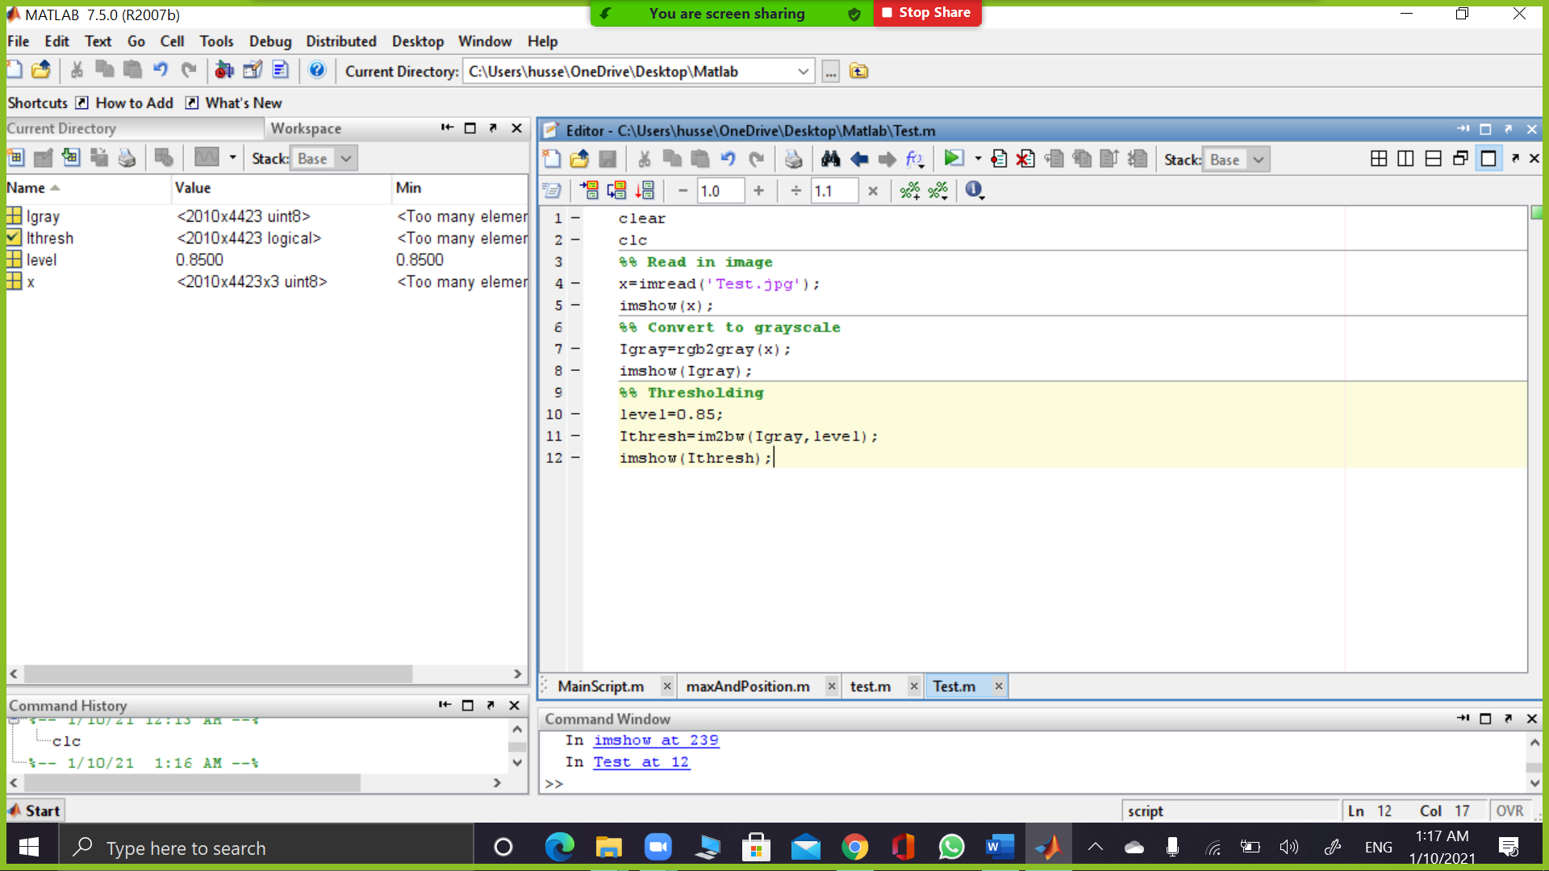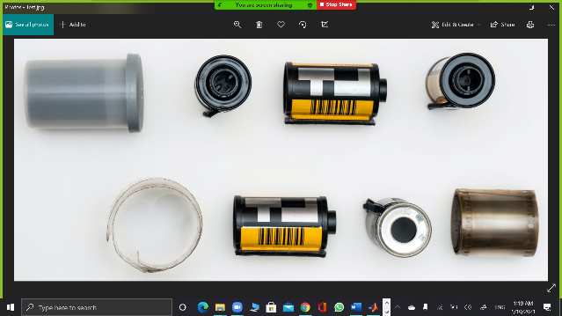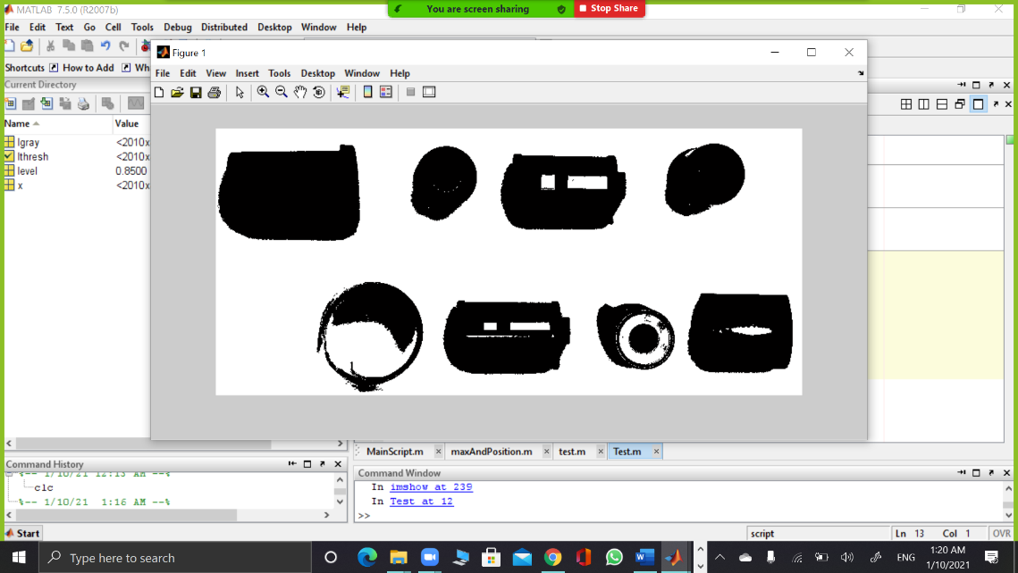

Code Original Image Processed Image

In the above algorithm the image was converted from RGB to greyscale then to binary. But as you can see the image here has the objects not completely filled so further processing would be inaccurate at all, so another approach must be taken.

1. **RGB Color Space**

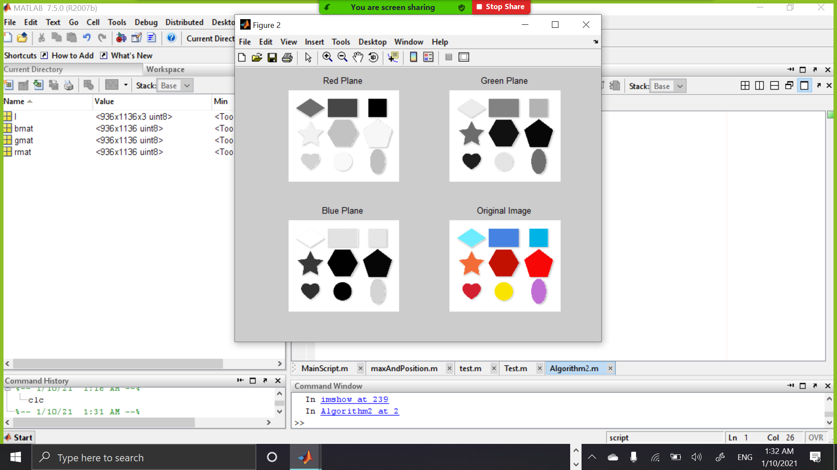

In this algorithm we seprated our image into 3 respective planes of RGB colours as shown, so this algoritm used a property of the image which is the colour of the image.

##### **Our Own Approach (A recap on our code):**

As mentioned above, those algorithms were not enough to get the objects in the image separated in the right way to be able to process different objects(blobs) in the most accuaret way possible, so to able to extract different informtaion.

* 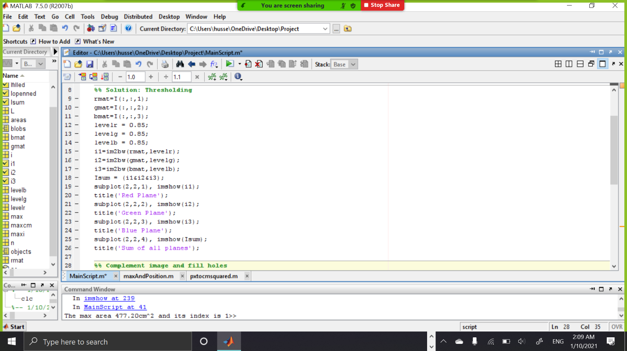A mixture between the above algorithms to get the best reusults of binary image as shown below:

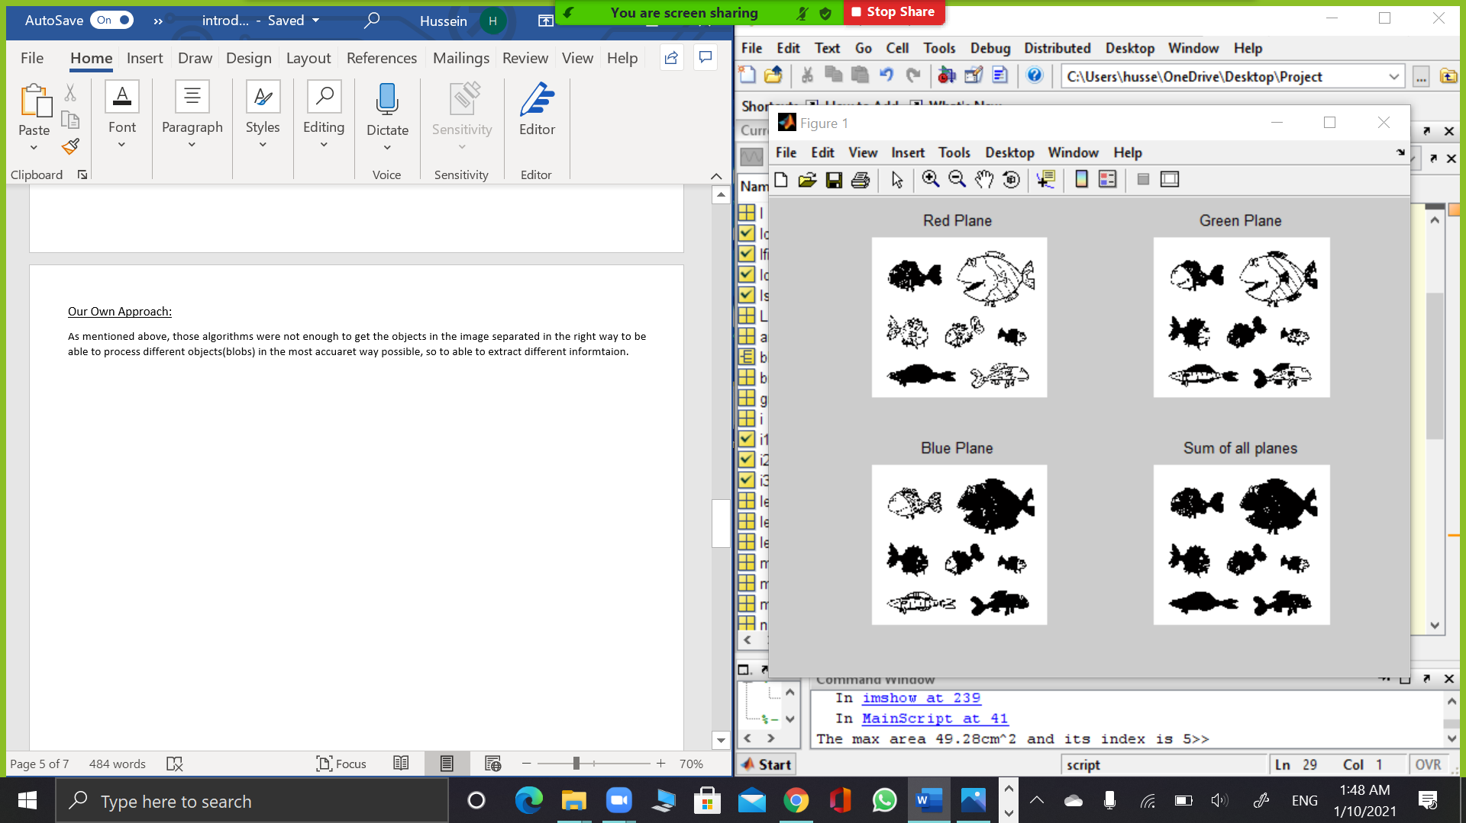

* After Color spacing, we summed up all planes to get an image that correctly determine the objects.
* Then as shown above in ‘The sum of all planes’ figure there are holes inside the blobs that should be filled with holes to act as a single object then we use imcomplement function to complenet the background and the foreground for easier vision and analysis.
* Strel function is used to enhance edges of images.

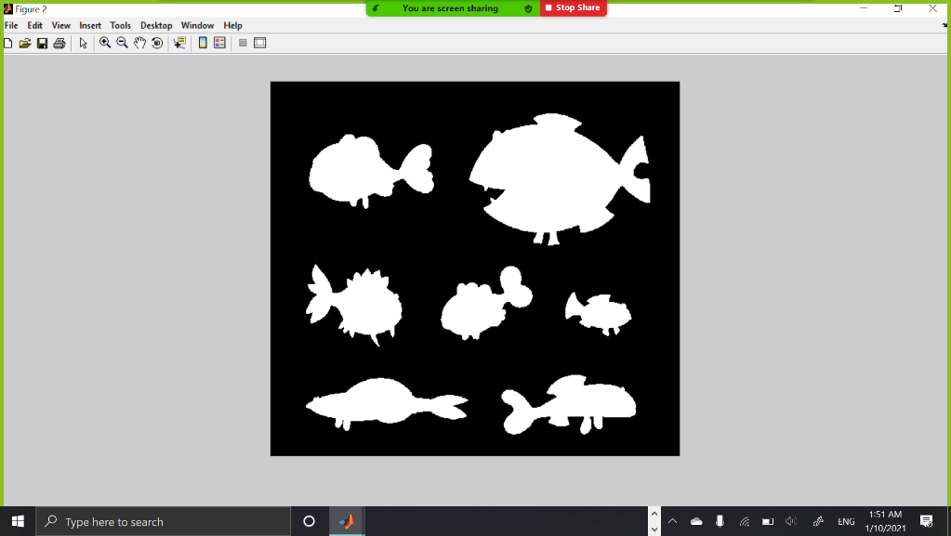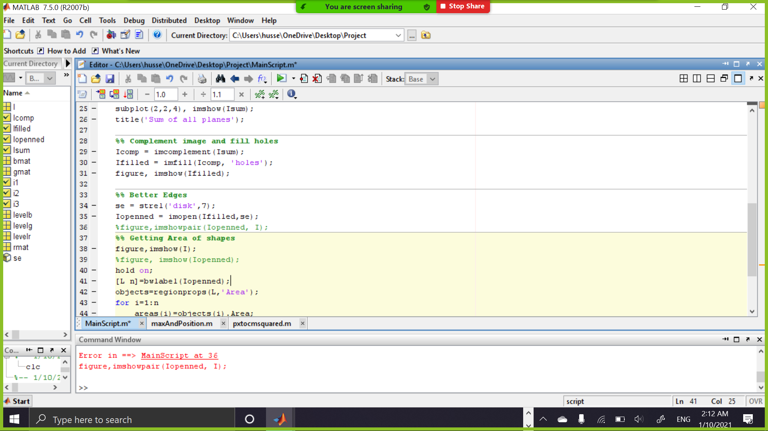

* And finally, the largest object is marked red and its area and index are determined in the command window.

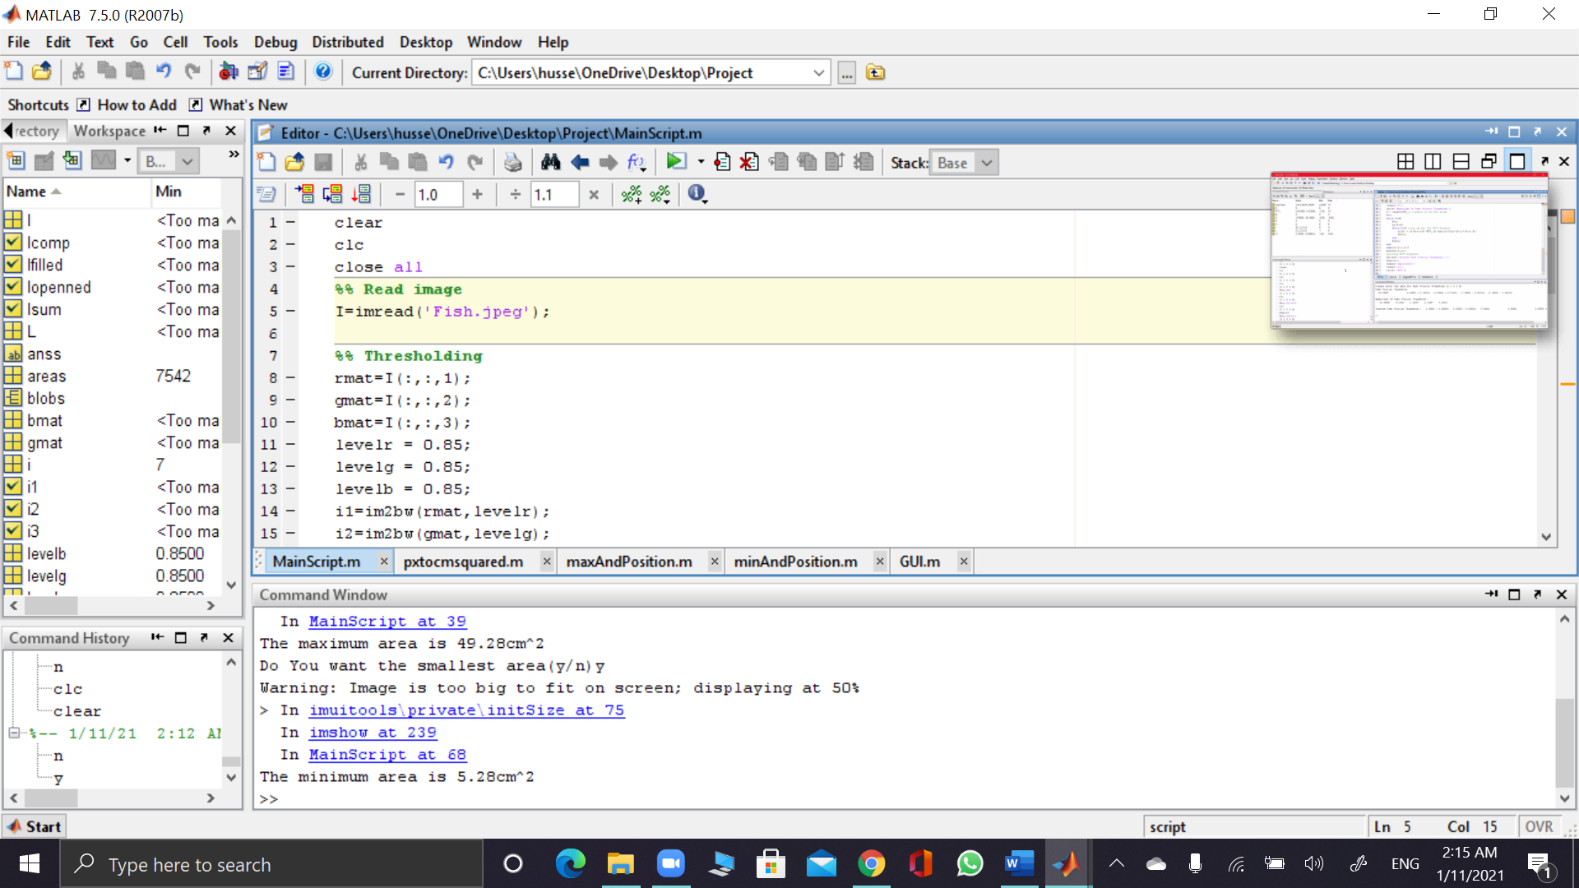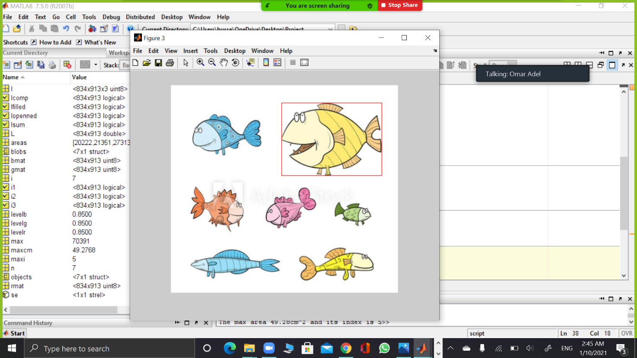

* 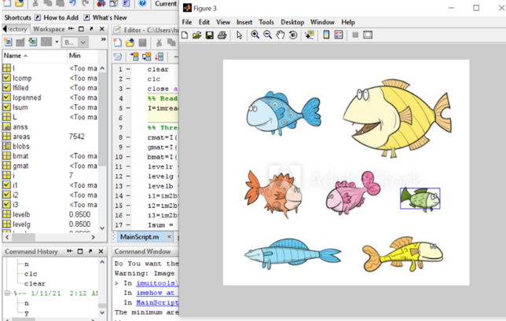Then the user is asked whether to choose the smallest object or end the program, if yes:

* If no:

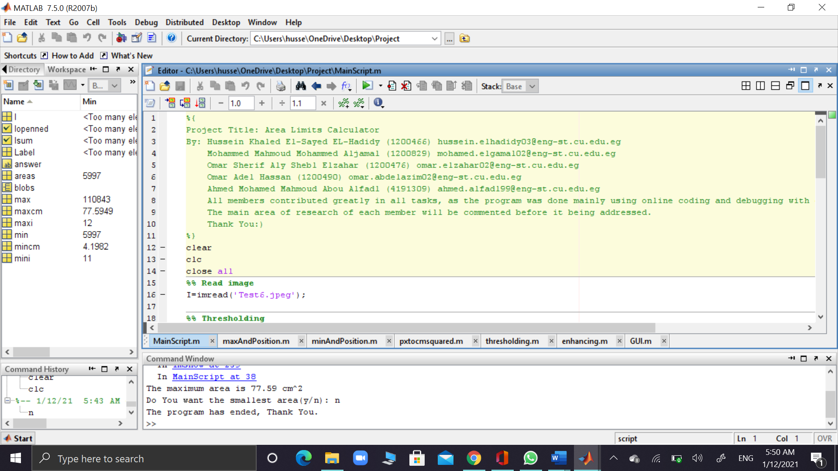

As is stands now, the program is ready in a CLI (Command Line Interface) form which is not user-friendly as it is subjective to errors during inputting the image for example with a wrong file format, so it came to our mind to

implement a GUI (Graphical User Interface) to ease the access for the user, as GUI’s features🡪WIMP (windows, icons, menus and pointers).

So, we used MATLAB’s simple design of GUI to convert our CLI into GUI, that was not a big deal, thanks to MATLAB’s built-in functions that makes it possible to build our own GUI with few steps as shown below:

1. First, we built the Design of the GUI:

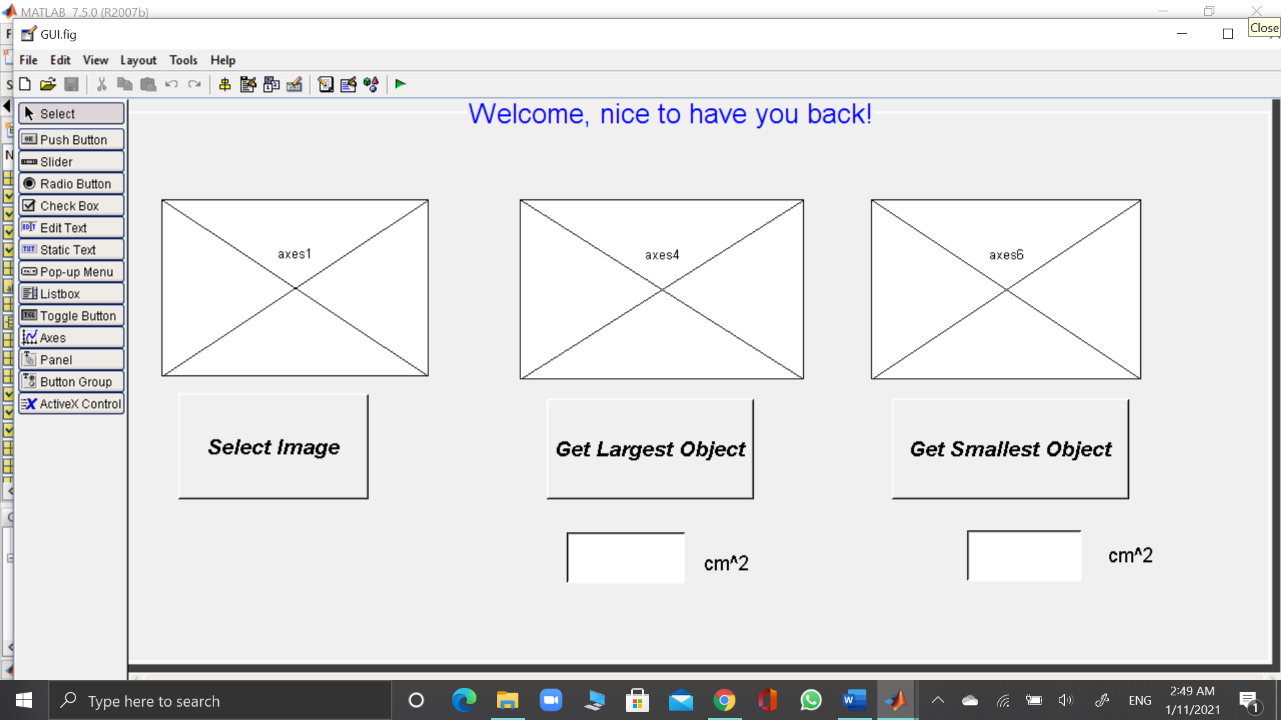

1. Then we started connecting our code to the Push Buttons shown above using simple functions such as axes() function.
2. We used imgetfile() function to help the user insert the image from his/her PC with ease using ‘Select Image’ button.
3. Here is our GUI in action:

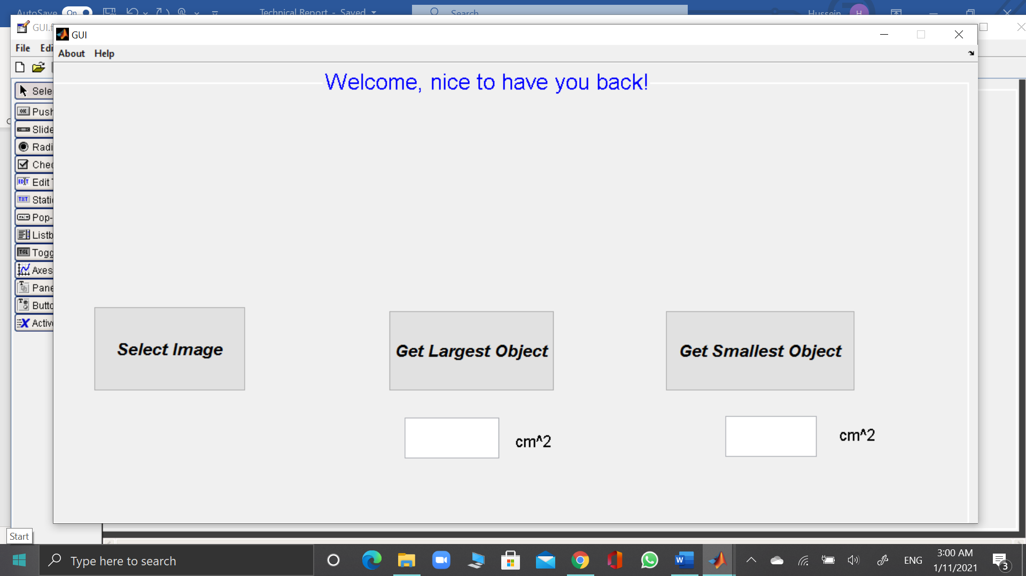

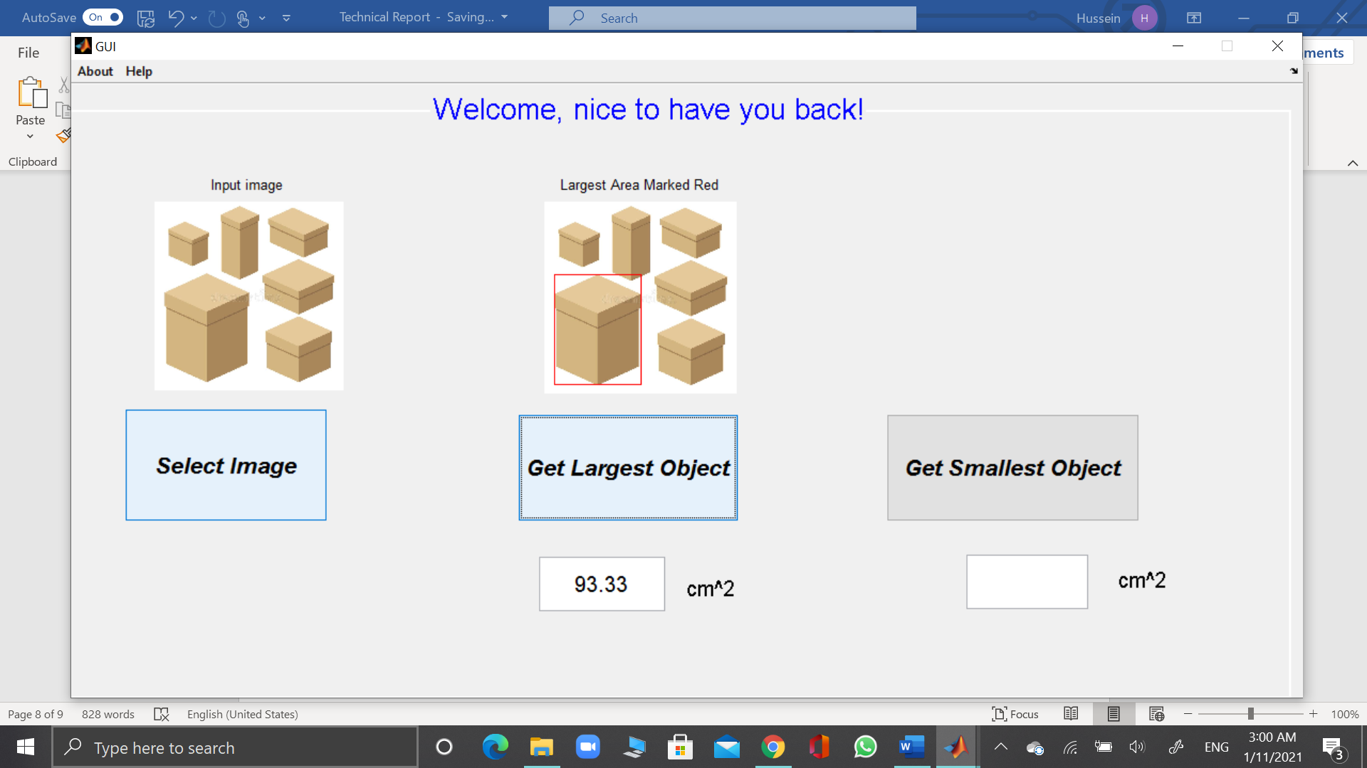

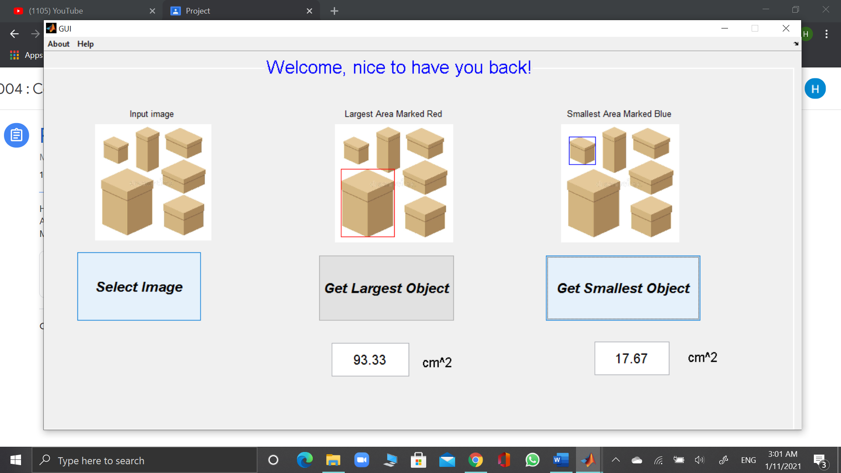

*Developers tab in GUI

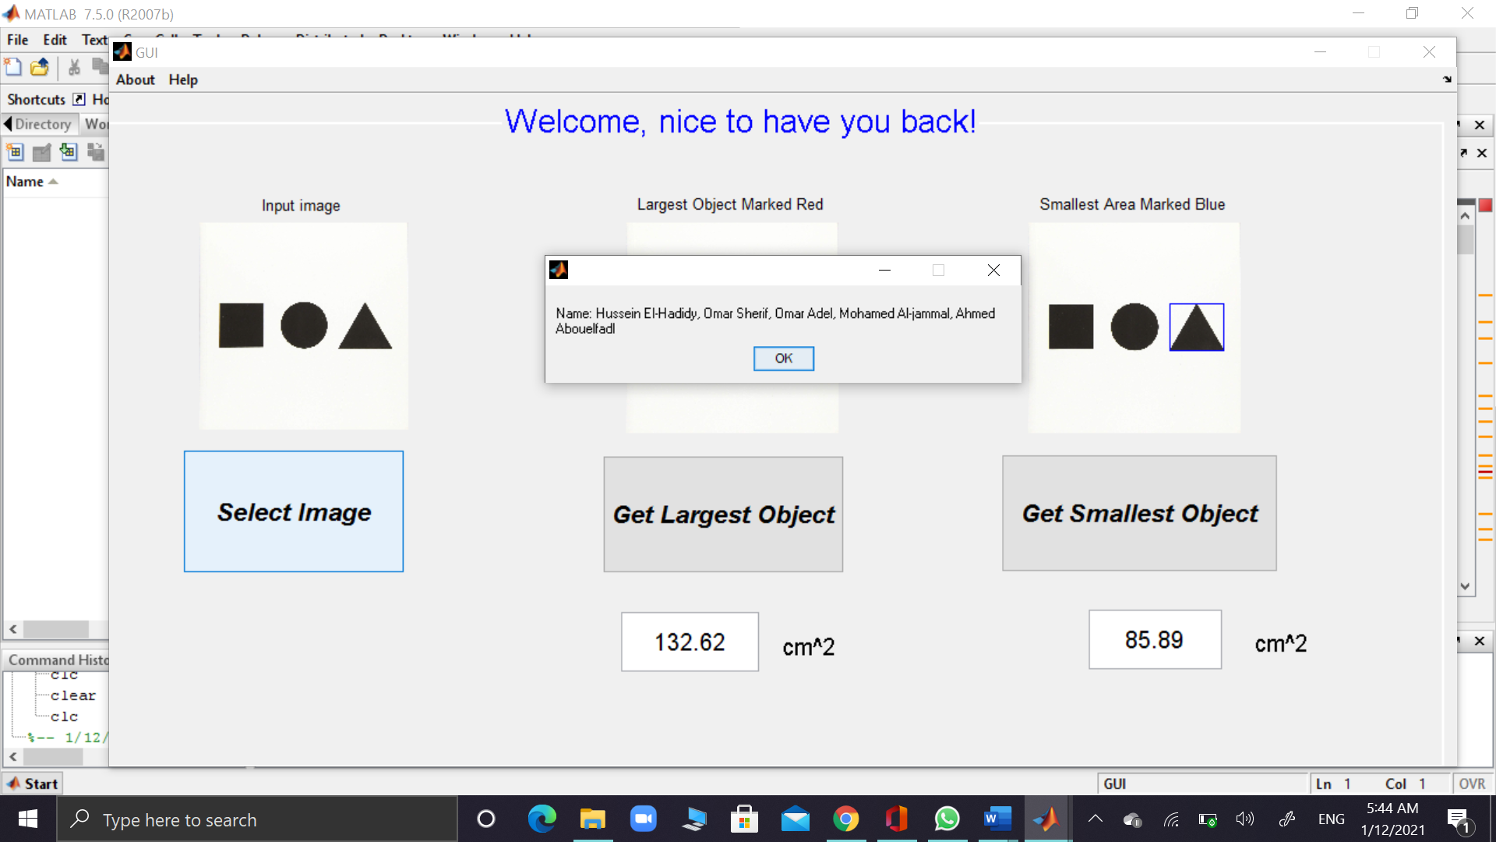

*Instructions tab in GUI

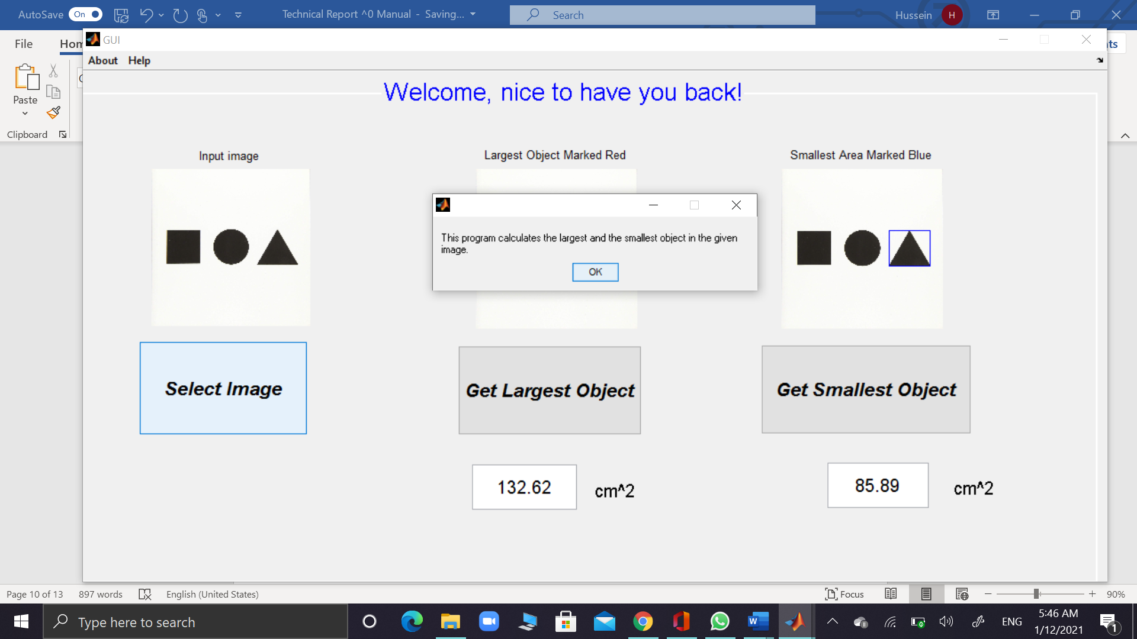

By this we have finally reached our goal in this project, special thanks to developers at MathWorks for their great implementation of GUI using MATLAB and now we will leave you with some samples of inputs and outputs :

1. This model demonstrates that our program works good with multi-coloured object.

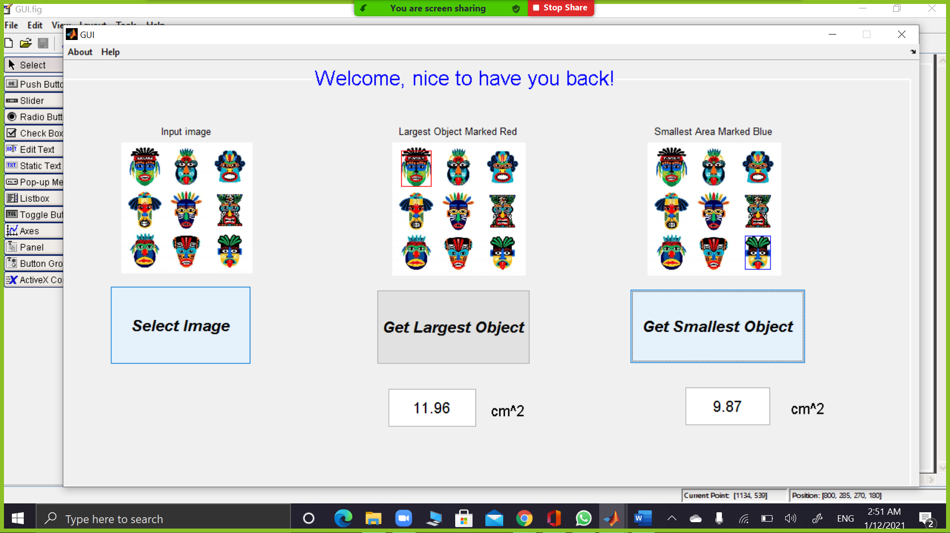

1. Here another sample showing leaves of 2 different sizes:

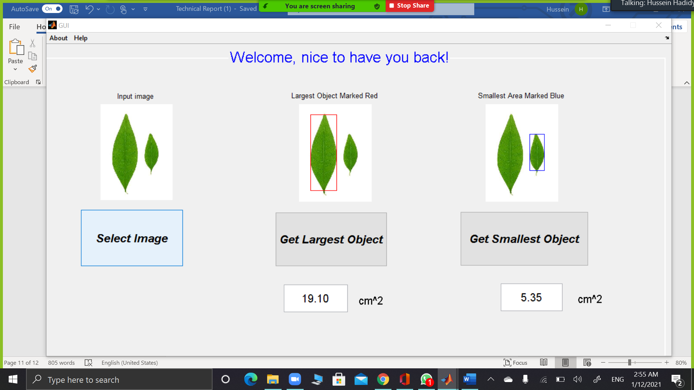

1. 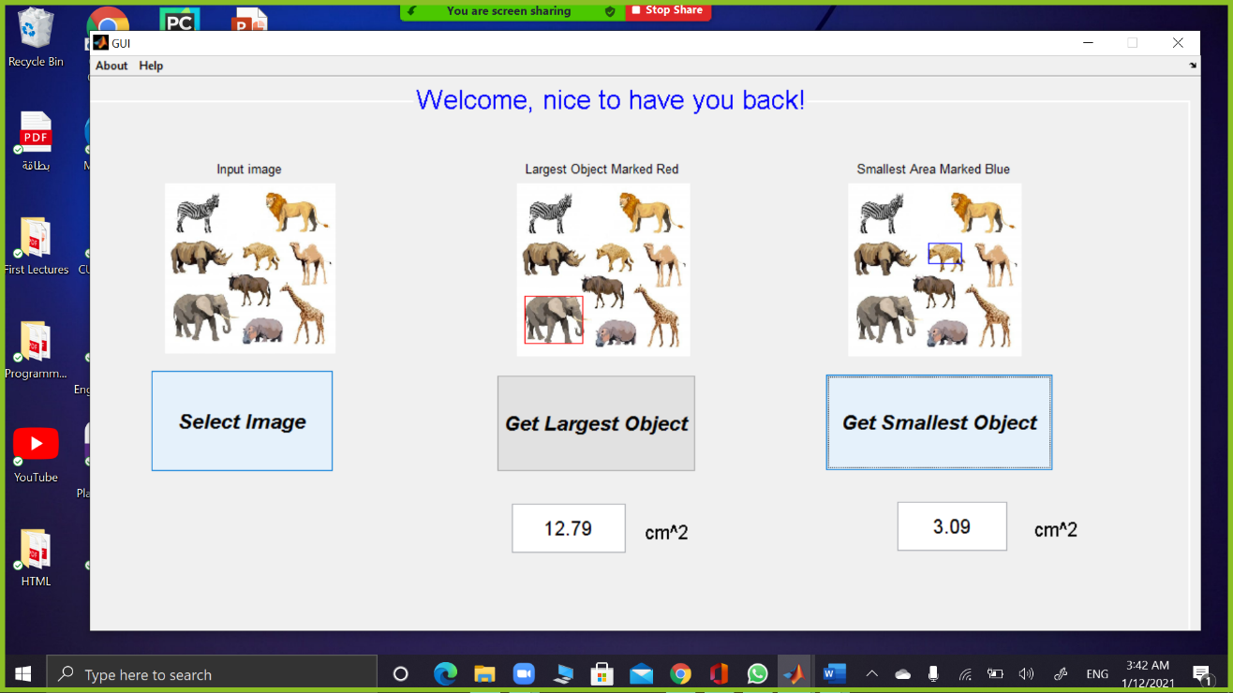Here another one showing animals of different sizes:

##### **How to use our program:**

Either one of 2 ways:

1- Using MainScript.m and the corresponding functions (CLI) format:

* maxAndPosition.m
* minAndPosition.m
* pxtocmsquared.m
* thresholding.m
* enhancing.m

2- Using GUI as previously discussed using the following file (Preferably):

* Open GUI.m file
* Run it then import an image (there are some test images supplied in the ZIP folder uploaded).

##### **Conclusion**

To sum up, our input is basically an image that is processed, and gives us the image with the largest object determined and its area calculated with a decent accuracy. Working as a team was different, as distributing programming tasks is different than any regular task, but surely it was a great and informative experienced that benefited us alot.